Ling 6 Sound Test – A Simple Way to Check a Child’s Hearing
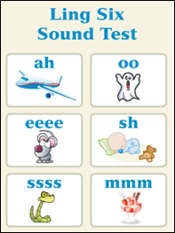
The Ling 6 Sound Test is a quick and easy way to check if a child can hear and recognize important speech sounds. These sounds help us understand how well the child can hear across the full range of speech. However, it is not an alternative of proper hearing evaluation done by audiologists.
What Are the Ling 6 Sounds?
The six sounds used in the test are:
- /m/ (as in “mmm”)
- /a/ (as in “ahh”)
- /u/ (as in “oo”)
- /i/ (as in “ee”)
- /ʃ/ (as in “sh”)
- /s/ (as in “sss”)
Each sound covers a different part of the hearing range, from low to high frequencies.
Age
The LING 6 Sound Check can be utilized in various ways to assess auditory responses across different ages and skill levels — from infants or newly implanted children to older, more experienced listeners.

How to Do the Test

1. Get Ready
- Choose a quiet place without background noise.
- Decide how the child will respond – by speaking, pointing to a picture, or using a toy.

- Gather materials, like pictures or toys for each sound (if the child isn’t responding verbally).

2. Present the Sounds
- Say each sound at a normal speaking level, not louder or exaggerated.
- Mix up the order of the sounds and add some pauses or silence so the child can’t just guess.
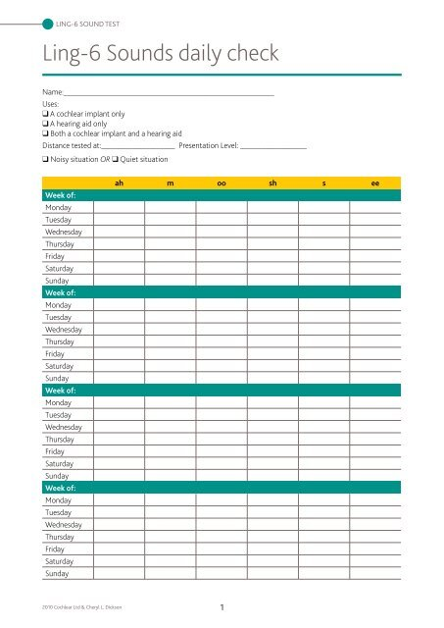
- Make sure the child can’t see your mouth, so they aren’t lip-reading.
- Keep the length of each sound about the same.

3. Watch and Record
- Note how the child responds – do they hear and recognize each sound?
- Praise correct answers to keep the child motivated.
- Keep a record of their responses using a simple chart or checklist.
Tips for Success
- Adjust for age and IQ level: Younger children and ones who struggles with understanding, may need more help or simpler ways to respond.
- Let them practice first: If the child hasn’t heard the sounds before, start with some fun play or demonstrations.
- Make it fun: Turn it into a game to keep the child engaged. For example, if he hears the sound, throw ball in basket.

Who Can Use the Test?
The test is simple enough that many people can use it:
- Parents and caregivers – to check hearing at home.
- Teachers – to make sure the child hears well in the classroom.
- Speech therapists – to help track listening and speech progress.
- Audiologists – as part of hearing tests and to adjust hearing aids or cochlear implants.
- Other professionals – who work with children with hearing loss or struggles to process and respond to the sounds.

Why Is the Ling Sound Test Helpful?
- Quick and easy – takes just a few minutes.
- No special equipment needed – you only need your voice and some basic materials.
- Checks hearing devices – makes sure hearing aids or cochlear implants are working.
- Supports learning – helps children improve listening and speech skills.

Ling Sounds and Autism
Children with autism may also benefit from the Ling 6 Sound Test. While not all autistic children have hearing problems, some may have difficulty processing sounds or paying attention to speech. The Ling Test can help:
- Check how well they detect and respond to sounds
- Support speech and listening therapy
- Track changes over time in sound awareness or reactions
- Reduce frustration by identifying if hearing or sound processing is affecting communication
Making the test playful and predictable can help children with autism feel more comfortable and engaged.

